Housemate Agreement

This agreement is made by and among the housemates:
, ,
, and ,
who have signed a lease with the property owner for a shared dwelling unit at this location:
.

Execution of this housemate agreement does not alter the joint liability of the tenants under the rental contract with the property owner. However, it may be used if a dispute among housemates arises.

Utilities (skip or delete if not relevant)
Ideally, utilities are included in the rent, but if not, housemates should review bills and payments monthly, based on a schedule, ensuring no one is stuck with the bill.

Housemates are responsible for following utilities (check all that apply)

[ ] Electric [ ] Natural Gas [ ] Oil [ ] Other (i.e., Water, Wi-fi)

List utilities and how each utility will be divided evenly:
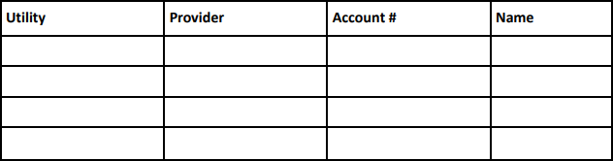

Housemates will divide each utility bill evenly as follows:

Guests
Each housemate is responsible for the behavior of their guests. Guests shall not unreasonably disturb other housemates. Does anyone have a friend or partner that will be around often?

Define who is a guest in your household:
, ,
, ,
, .

What spaces are off-limits?
, ,
, ,
, .

When/how should you notify the other housemates if someone is coming over? All guest-related policies that housemates have agreed upon are stated below:

Quiet Hours
Housemates agree when to observe quiet hours for sleep, study, and other purposes on the days and times listed here. Be mindful of each other’s needs.

Weekdays
From to
From to

Weekends
From to
From to

Property Owner Communication
Housemates agree to talk to each other before communicating with the property owner.

Food/Groceries
Each individual housemate will purchase their own food. If a housemate did not purchase it, they will not eat it or offer it to a guest without permission, except for community items. Food is labeled, and each owner eats only their own food.

Identify housemates' food allergies and what is needed for health and safety.

Community items will be purchased so all housemates can use them, and the cost will be shared equally.

Community Food Items:
, ,
, ,
, .

Household Cleaning Supplies:
, ,
, ,
, .

Additional Notes:

Kitchen Tips: Have a household discussion regarding the types of foods to be cooked to understand and respect cultural differences. Note that food smells and/or products can be challenging for others in the house. Discuss how to respect each person’s preferences.

Specify kitchen agreements:

General Courtesies
A housemate’s room is their private domain. The room’s occupant has complete control over what goes on unless they are doing something that could harm or endanger another.

If any housemate moves out of the unit for any reason, that housemate is responsible for giving at least 30 days’ notice to other housemates if possible and paying their fair share of the rent and utilities until the termination of the lease. All housemates shall decide upon anything that affects all housemates.

Additional Agreements/Deal-breakers
List additional agreements and deal breakers housemates agree to prioritize:

How do we respond if a housemate breaks the household agreement regarding drug and/or alcohol use?

By signing my name, I understand and agree to all terms in the contract and will abide by these terms.

Name: Date:

Name: Date:

Name: Date:

Name: Date:

This is a living document. To discuss updates on this housemate agreement and other household matters, housemate meetings will be held (check one)

[ ] Bi-weekly [ ] Monthly [ ] Annually

